CHATBOT IN PYTHON

**Building the Chatbot by preparing the Environment and Implementing basic user interactions**



*Define the Chatbot's Purpose and Goals:*

Determine the specific problem the chatbot will solve or the task it will assist with.

Define the target audience and their needs.

Set clear objectives and success criteria for the chatbot.

*Choose a Chatbot Platform:*

You can build a chatbot from scratch using programming languages like Python, or use chatbot development platforms and frameworks like Dialogflow, Microsoft Bot Framework, or Rasa. Select a platform that aligns with your project's requirements.

*Data Collection and Preparation:*

Collect and organize the data needed for the chatbot. This includes potential user queries, responses, and any relevant data sources.

Annotate and label data for training purposes, especially if you plan to use machine learning.

*Select the Technology Stack:*

Decide on the technology stack you'll use, including programming languages, libraries, and tools. Common choices for building chatbots include Python, Node.js, and Java

*Develop the Chatbot:*

Write the code to create the chatbot's functionality.

Implement Natural Language Processing (NLP) and Natural Language Understanding (NLU) to understand user inputs. Integrate with external APIs or databases, if necessary.

*Testing and Training:*

Test the chatbot extensively to ensure it understands user inputs and responds correctly. Train the chatbot using machine learning techniques if your platform supports it. This may involve using annotated data for training

*User Experience Design:*

Design the chatbot's user interface and user experience to make interactions intuitive and user-friendly. Consider using a conversation flowchart to plan how the chatbot will handle various user inputs and scenarios.

*Security and Data Privacy:*

Implement security measures to protect user data and ensure that sensitive information is handled securely. Ensure compliance with data privacy regulations such as GDPR.

*Deployment:*

Deploy your chatbot to a hosting environment. Cloud platforms like AWS, Azure, or Google Cloud are popular choices. Make the chatbot accessible to users through web applications, messaging platforms, or mobile apps.

*Monitoring and Maintenance:*

Monitor the chatbot's performance, user interactions, and system health. Continuously improve and update the chatbot based on user feedback and evolving requirements.

*Integration and Scaling:*

Consider integrating the chatbot with other systems or platforms, such as CRM or e-commerce platforms, to expand its capabilities. Plan for scalability to handle increased user demand.

*Documentation and Support:*

Create user documentation and provide support channels for users to get assistance if they encounter issues*Compliance and Regulations:*

Ensure that your chatbot complies with relevant regulations, especially if it handles sensitive data or provides financial, healthcare, or legal advice.

*Marketing and Promotion:*

Promote your chatbot to the target audience and encourage its use. Building a chatbot is a complex process that may require expertise in programming, NLP, and user experience design. Depending on the complexity of your project, you may need a team of developers, data scientists, and designers to create an effective chatbot

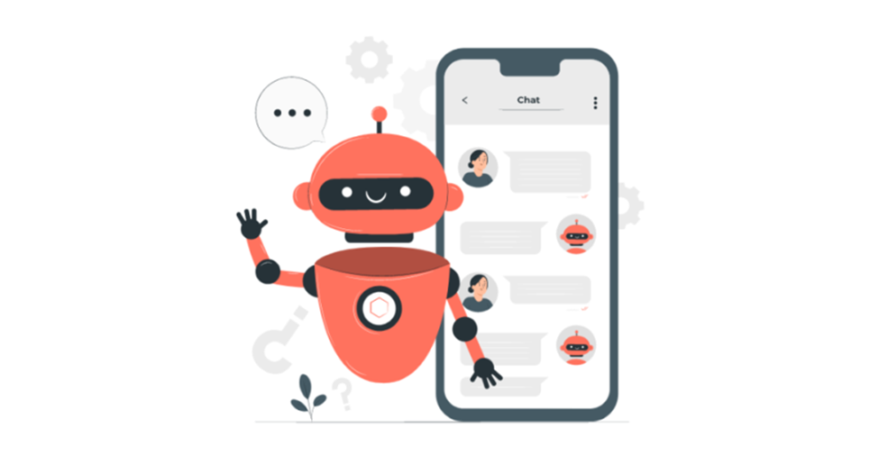

** Implementing basic user interactions for build a Chatbot**

*Select a Programming Language and Framework:*

Choose a programming language and chatbot framework that best suits your needs. Common choices include Python (using libraries like NLTK, spaCy, or Rasa), Node.js (using libraries like BotKit), or platforms like Dialogflow or Microsoft Bot Framework.

*Initialize Your Project:*

Create a new project directory for your chatbot. Set up the necessary development environment, including the required libraries and tools.

*Define Your Chatbot's Purpose:*

Clearly define the primary function and objectives of your chatbot. What is the bot supposed to do or assist with?

*Collect and Annotate Training Data:*

Gather example user queries and their corresponding expected responses. Annotate the training data to indicate the intent of the user's message and any entities or variables involved.

*Implement Natural Language Processing (NLP):*

Use NLP libraries or services to analyze user inputs. This includes tasks like tokenization, part-of-speech tagging, and entity recognition. Determine the intent and entities in the user's message to understand what they're asking or stating.

*Design Conversation Flows:*

Create conversation flows or decision trees that outline how your chatbot should respond to different user inputs. Plan for various user scenarios and error

*Select a Programming Language and Framework:*

Choose a programming language and chatbot framework that best suits your needs. Common choices include Python (using libraries like NLTK, spaCy, or Rasa), Node.js (using libraries like BotKit), or platforms like Dialogflow or Microsoft Bot Framework.

*Initialize Your Project:*

Create a new project directory for your chatbot. Set up the necessary development environment, including the required libraries and tools.

*Define Your Chatbot's Purpose:*

Clearly define the primary function and objectives of your chatbot. What is the bot supposed to do or assist with?

*Collect and Annotate Training Data:*

Gather example user queries and their corresponding expected responses. Annotate the training data to indicate the intent of the user's message and any entities or variables involved.

Implement Natural Language Processing (NLP):

Use NLP libraries or services to analyze user inputs. This includes tasks like tokenization, part-of-speech tagging, and entity recognition. Determine the intent and entities in the user's message to understand what they're asking or stating.

*Design Conversation Flows:*

Create conversation flows or decision trees that outline how your chatbot should respond to different user inputs. Plan for various user scenarios and error

**Required Libraries**

OpenAI Python Library (openai): This library is provided by OpenAI and allows you to interact with the GPT-3 API. You can use it to send prompts and receive responses from the GPT-3 model.

You can install it using pip:

**pip install openai**

Requests (requests): To make HTTP requests to the GPT-3 API, you'll need the Requests library. It's a popular library for sending HTTP requests in Python.

You can install it using pip:

**pip install requests**

Here's a basic example of how you can use these libraries to interact with the GPT-3 API:

Program:

import openai

import requests

import json

api_key = "YOUR_API_KEY"

openai.api_key = api_key

prompt = "Translate the following English text to French: 'Hello, how are you?'"

response = openai.Completion.create(

engine="davinci",

prompt=prompt,

max_tokens=50,

n = 1

)

generated_response = response.choices[0].text

print("GPT-3 Response:", generated_response)